

GLOBAL 2011

Presentation Manual

Dec. 11-16 2011
Makuhari Messe, Chiba, Japan

Contents
Instruction for Material Preparation ...............................................................1

Oral Presentation ...............................................................2

Poster Presentation ...............................................................4

Biography form ...............................................................5

Oral Presentation | Poster Presentation
- Presentation | - Size
- Power point 2007 or Adobe Reader.  - 15min presentation, 5min discussions | - Poster board provided A0 size; (~110cm high, ~ 80cm wide)
- Attention | - Attention
- Do not use special fonts, which might not be displayed.  - Do not send any presentation files by E-mail to GLOBAL secretariat. | - Do not mail your poster to the GLOBAL secretariat or to the meeting site as there will not be anyone to accept your posters at those locations.
Instruction for Material Preparation

Oral Presentation
Instruction at the Meeting

Presentation file
/If you would like to use your own PC, you can connect your PC and LCD computer projector at presentation room with analog cable, available at the meeting room.

/If you would like to use PCs provided by GLOBAL committee at the meeting room, you must bring your own electronic data with your USB memory devices and/or CD ROM, and make a copy onto the computer at the day of your presentation in the meeting room

Audiovisual equipment
The following audiovisual equipment will be available during the meeting:
Standard equipment set: (In each room)
- Laptop computer
  - OS: windows 7
  - Software: Microsoft PowerPoint 2007” and ”Adobe Reader”.
  - Analog cable (in case using your own PC)
- LCD computer projector
- Electronic pointer
- Microphones
- Cards (Red and Yellow)
- Other audiovisual presentations will not be supported.

Preparing your presentation
- Do not use special fonts, which might not be displayed
- Do not send any presentation files by E-mail to GLOBAL.

Biography
- Please fill out attached biography form and hand over it at the registration desk.
At the meeting

When you arrive at the conference hall in Makuhari messe
- When you arrive, review the Program and Program Change Sheet for changes and updates in room or time.

The day before your presentation -- Preview Room
- GLOBAL committee provides a Preview Room at the meeting that is equipped with a laptop computer. A staff member is available to assist you to check your presentation files during operating hours. (close:18:00)

At the time of your presentation
- If you are not going to use your own PC and you would like to copy your presentation files onto the computer, please arrive in your scheduled meeting room at least 15 minutes before the start of your presentation session. Introduce yourself to the session moderator. And copy your presentation files onto the laptop computer, set at the meeting room.

Oral presentation
- Sessions are typically 90 and 120 minutes long with five and six speakers, respectively, each giving a 15-minute talk with 5 minutes for questions. An appointed session chair (listed in the program) will moderate the session.
  - Speakers are strictly required that the each presentation should NOT exceed 20 minutes.
  - The session chair will indicates yellow card that the speaker has 3 minutes remaining.
  - At the end of 3 minutes(total 15 minutes), a red card is indicated meaning the end of the presentation.
  - A maximum of 5 minutes is allowed for discussion.(total 20 minutes)

Poster Presentation

Preparing your poster presentation
- The size of your poster should fit the poster board provided
(A0 size; ~110cm high, ~ 80cm wide)
- Do not mail your poster to the GLOBAL office or to the meeting site as there will not be anyone to accept your presentation at those locations.

The poster session schedule
Dec. 14, 8:00 ~ Dec.15 12:30

Dec. 14, 8:00~ | Poster set-up start.
Dec. 14, 18:00 ~ 20:00  (Core time) | All poster presenters must be present during the core time.  (Light snack is provided)
Dec.14, 20:00 | Poster presentation Award
Dec 15, 12:30 | The poster should be removed before Dec 15 12:30.

Poster Awards
- GLOBAL committee has prepared poster award to honor people for excellent work.
- GLOBAL will give the each award winners a testimonial and mementos (Uranium Glass).

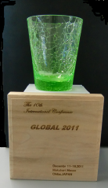
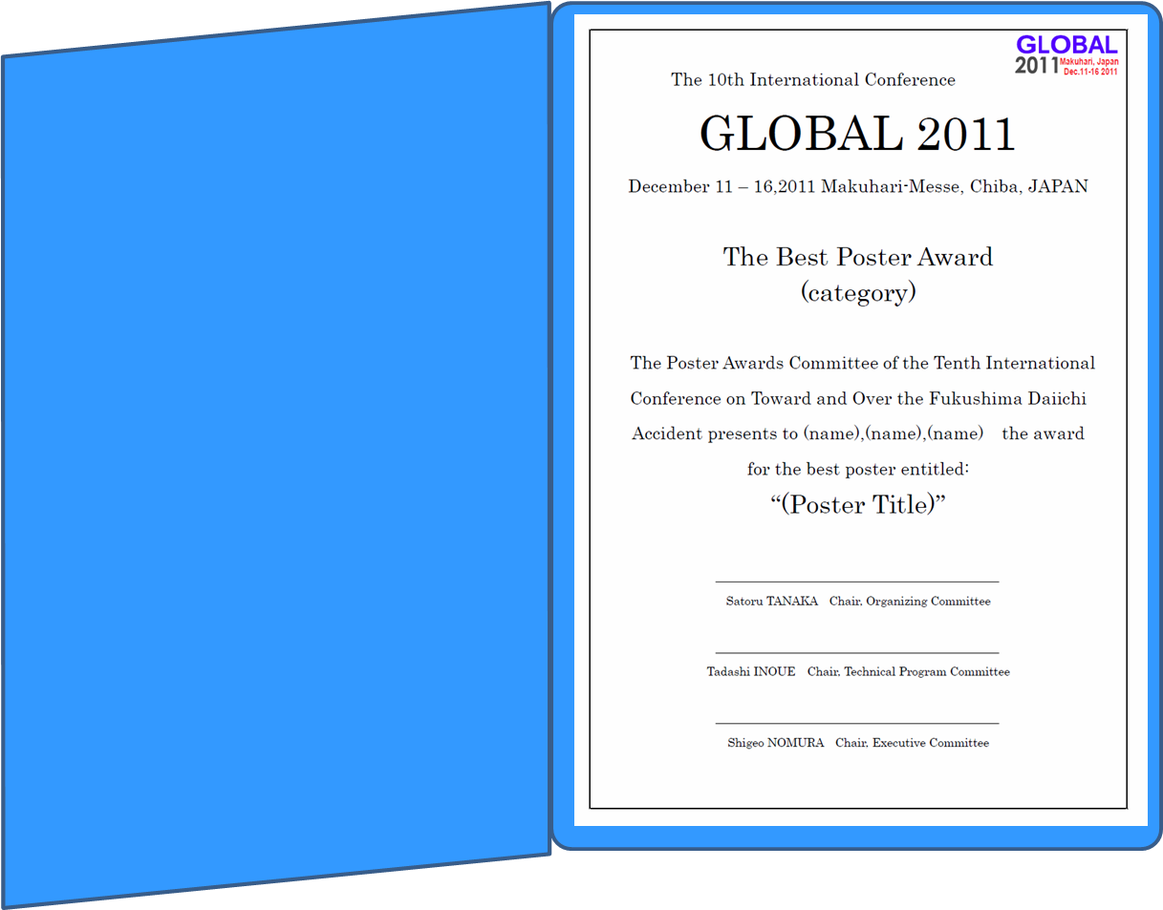

GLOBAL 2011 Speakers Biography
Topic (Please check the left side column for your presentation topic)
 | 0) Fukushima Daiichi Accident
☆Global Prospects of Nuclear Energy
 | 1) Nuclear development strategy
 | 2) Sustainability and optimization of nuclear systems
 | 3) Future fuel cycle strategy
☆Advanced / Innovative Fuel Cycle Systems and Technologies
 | 4) Advanced fuel cycle system (LWR to FR transition)
 | 5) Partitioning & transmutation
 | 6) Advanced reprocessing technology
 | 7) Advanced fuel / target and materials
 | 8) Innovative nuclear energy systems beyond 2030
☆Current Fuel Cycle Technologies and their Improvements
 | 9) Current reprocessing and verification / solidification
 | 10) Radioactive waste treatment and disposal options
 | 11) Spent fuel management
 | 12) Uranium resource and fuel supply
☆Next Generation Reactors
 | 13) Advanced reactors (FR, HTGR, SCWR, small reactor, molten salt reactor)
 | 14) Nuclear safety
 | 15) Nuclear hydrogen and other utilization
☆Nuclear Nonproliferation
 | 16) Safeguards, nuclear security and related technologies
 | 17) Multilateralization of nuclear fuel cycle
☆International Collaboration and Public Acceptance
 | 18) International collaboration, research resource and development structure
 | 19) Social issues and public acceptance
 | 20) Human resource development
Presentation Date |  |  | Presentation Room
Name
Affiliation
Biography

